How to Repair the Epson 7600/9600 Printer
Epson printers are well designed and have been proven to be the leading printers for photography, display, and fine art. They are low in cost as compared to professional printers made from Mimaki, Mutoh, and Roland and have led the field in pigment inks. Their progress in technology this has been valuable for the advancement in Digital Printing. However, Epson printers need to be maintained just as the other professional printers. We have prepared guides to help you maintain and repair your Epson Printers.
The knowledge I am about to impart has come from our experience in maintaining and repairing Piezo inkjet printers. See our website for Support on Maintenance and Repair.

When you buy parts from us, you get our help and support.
- Epson printers are not user friendly for cleaning or maintaining. The pads of the capping station, the wiper, the bottom of the heads and dampers are not easily accessible.
- Our guide to maintenance will allow you to keep your printer running well for years.
- Epson does not promote daily maintenance. Pigment ink will dry on the docking station where the heads sit if the printer is not used daily. Pigment particles need to be broken up to allow the pads of the docking station to properly perform routine head cleaning.
- We have developed a powerful cleaning fluid CLF1 to be used in an eye dropper bottle for easy maintenance.
- Epson offers a one year warrantee, but does not inform you when servicing is needed what the cost will be.
- We are offering instructions on the replacement of parts.
- From the time you start printing, the printer counts actions and when it reaches the designated number it shuts down the printer. This usually happens after the first year, just when the warrantee is over.
- We can supply you with the codes to reset the counters, and put your printer back in operation.
Replacing the Dampers, Wiper, Capping Station, Flushing Box, and or Head:
In order to replace the dampers or the head you need to remove the covers. Follow the next steps. Remember the Printer must be unplugged.
In order to just replace the wiper and clean the capping station scroll down the page to where it states Locating the Capping Station.

By removing the following screws you will be able to safely remove the printer side and top covers. You should remove both sides of the Printer. Be careful to remove the control panel. Remove the Screws first. Look over the entire guide to get an overall understanding of what is involved. This whole procedure should take about 20 minutes.

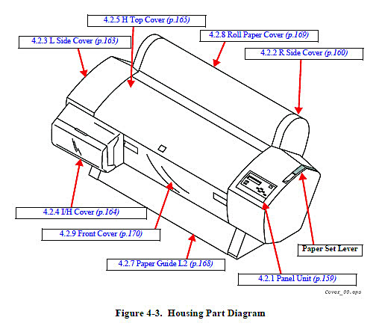
In order to remove the right side the control panel must be removed from the right side cover. To accomplish this you must press the two sides of the panel to unclip it. Be careful because under the panel is a cable that is connected to the panel and the control board. Once you remove the sides and cover panel you may want to reconnect the panel control and tape it to the frame for testing once you finish repairing your printer.
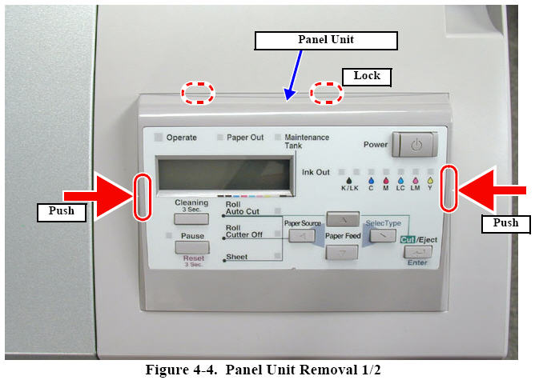
This is the underneath cable connection.
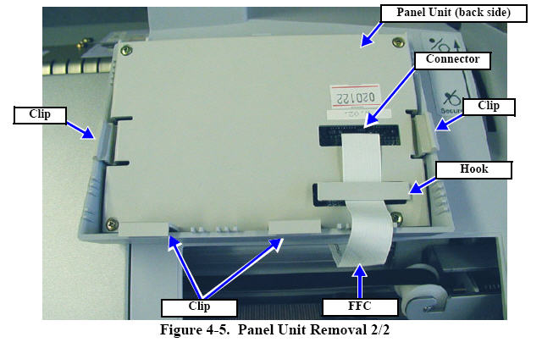
Remove the lever blind cap and the two black screws holding the paper lever. Remove the rest of the screws as shown in the diagrams below.
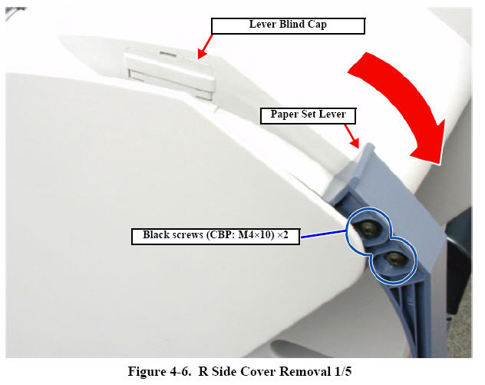
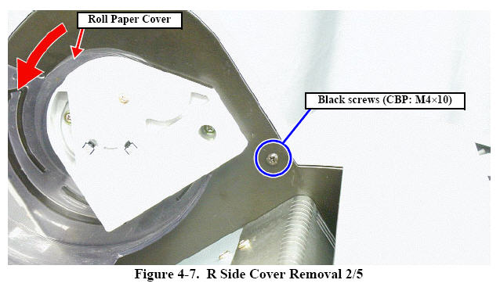

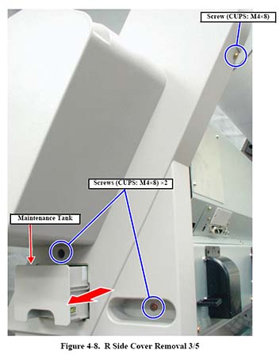

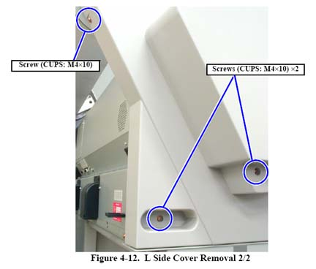
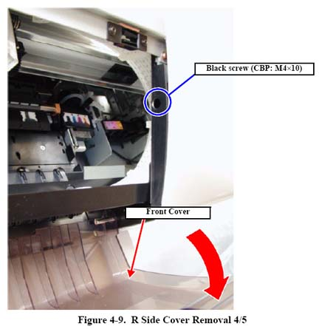

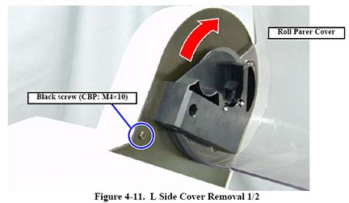

Remove the Cartridges from the printer.
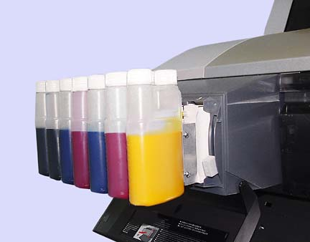
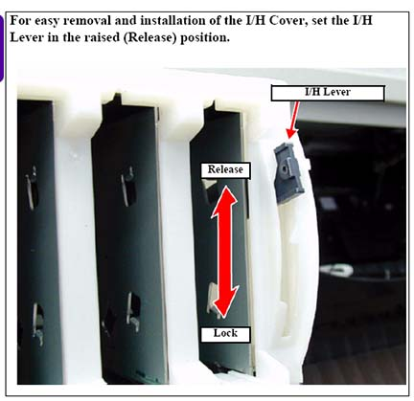
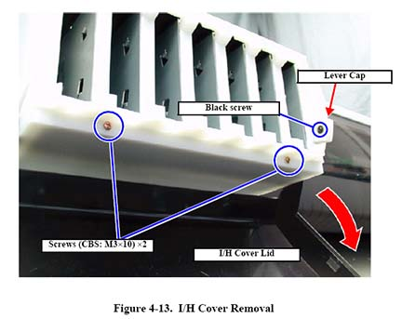
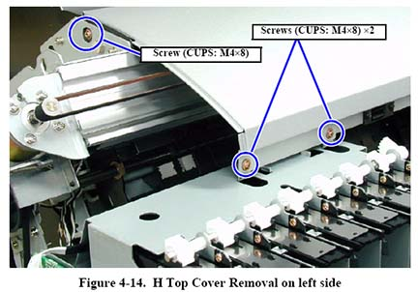
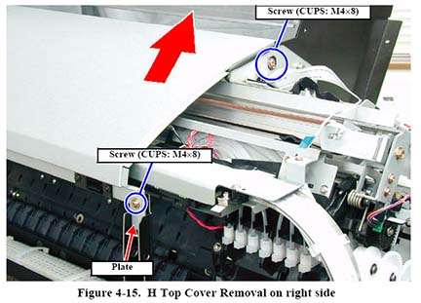
Locating the Capping Station
This diagram shows an overview of the inside of the 7600/9600 printer. In order to get access to the inside of the printer, we have prepared a step by step removal of the covers. The capping station is where you place droplets of CLF007.
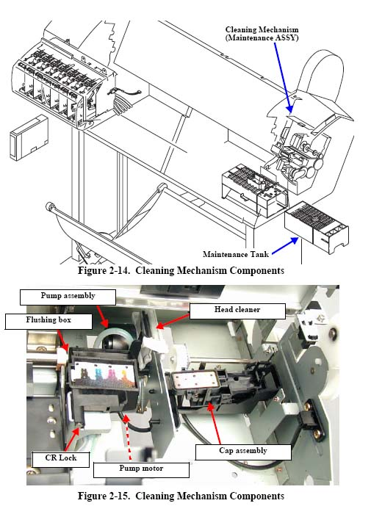
This is what it looks like when in use. With the use of cleaning fluid placed on the pad frequently, it will remain free of ink build up.
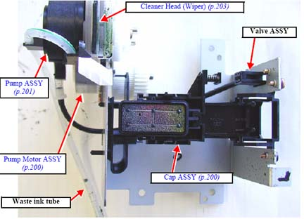

To the left of the capping station is the Flushing Box. The pad will become saturated over time. The printer head passes over this pad to spray all the nozzles every so many passes in order to prevent the nozzles from drying. It is important to make sure that the pad does not protrude upward.
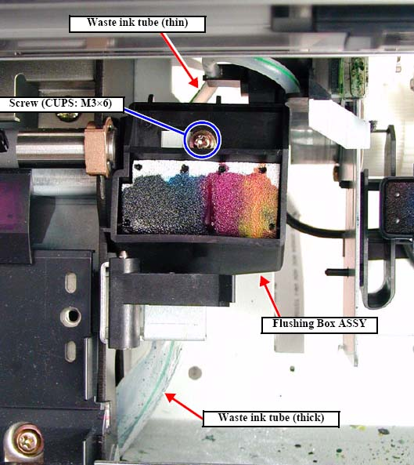

Note how the wiper is held in place. In order to replace the wiper you will need a needele noze plyers or a pair of twezers. Grab then bottom of the wiper and pull down and out away from thewn clips and then pull it straight up and out. You do not need to remove the covers, but you need to be careful.
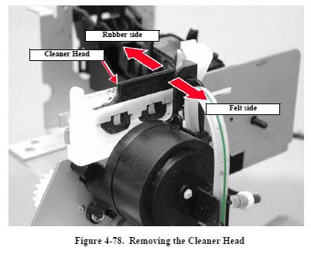

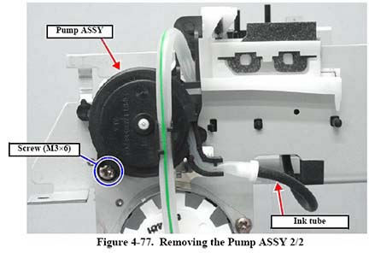
In order to move the head of the capping station, you need to push down on the cutting blade gently and push the carraige aside to the left. This will allow you to get to the capping station and wiper.
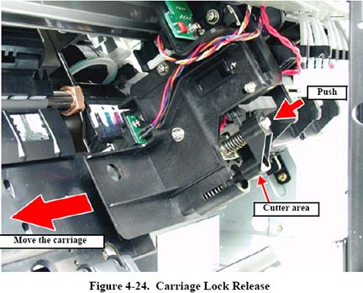
At this point you should have the printer cover removede and have complete access to the carraige. Move the carraige to the center of the printer and make sure you have paper under the carraige head. Place paper towels around youir working area,m because ink will drip at some point.

Replacing Dampers
With the carraige place in the middle of the printer, remove the screw as shown. You will need a philips head screw driver. Place you opposite hand finger under the carraige and feel the screw. Then place the screw driver straight down to you feel the catch of the head. Gently unscrew. On some printers the screw will only release but not be removed.
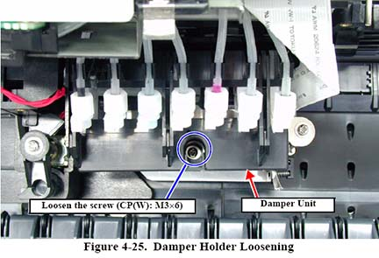
Remove the dampers by pulling them up and over to you. Do not touch the lever on the right. If youi plan to replace dampers, you must unclip the hooks as shown below. You may want to check each damper while you have the unit apart. To remove a damper you need to unscrew the white nut. Be careful not to loose the o ring under the nut. I suggest you replace each damper one at a time so as not to mix up the order.
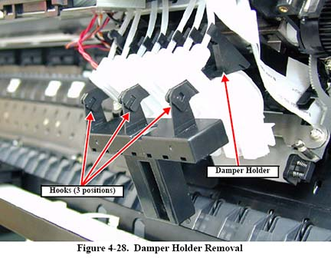

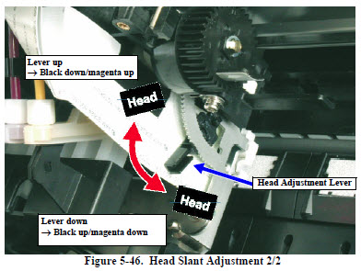
Note the round silver disc in the damper where the two red arrows are pointing toward. This is the filter and the one way valve to prevent ink from backing up from the capping station to the damper. If it is not clean it will not let ink through to the head.
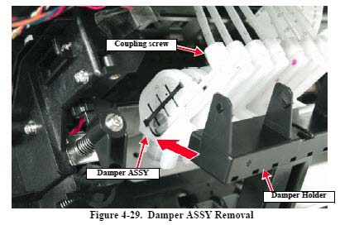
To Remove the Head
Before removing the head make sure the dampers are placed out of the way. You may want to string them up with a rubber band.
When removing the head loosen the screws as shown below and drop the metal blade out of the way. Pull the head out and remove the two ribbon cables. Handle the head carefully. Do not put pressure on the bottom of the head.

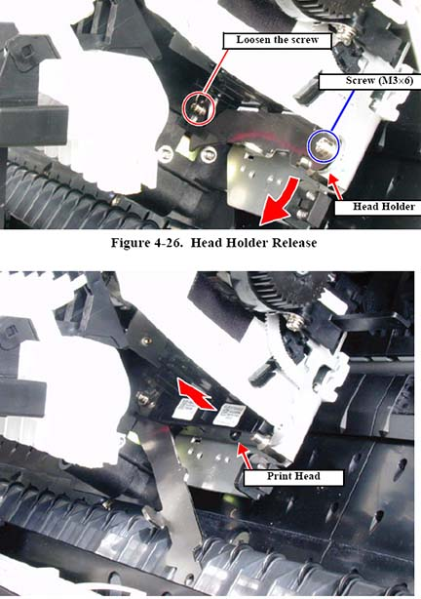
Note, there are two sets of codes. Use the appropriate one for the type of ink you are using.

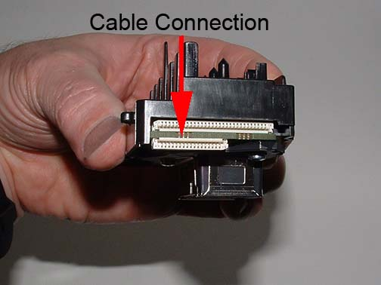
Note, there are two sets of codes. Use the appropriate one for the type of ink you are using.

